LIFE BEYOND THE PORTALS: DEBBIE DROSS
by Thalia Doukas for the FEPOC Newsletter
We had heard that Programmer Debbie Dross races motorcycles. We found out that she commutes to work on a 2006 Suzuki Hayabusa, a bike she built, maintains and races at record-breaking speeds. Read on, to find out more ...

Could you share some of your amazing racing credentials? I am one of only seven women in the world in a recognized, sanctioned Land Speed Racing (LSR) 200 MPH Club on a motorcycle. Basically, that means I’ve successfully raced my motorcycle to a speed of 200 mph. In all but two of the LSR venues it is also required that you make a record over 200 mph to gain entry into the club. To do that, you have to run faster than the prior racers in a given motorcycle configuration class and exceed 200 mph.
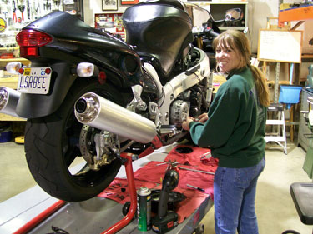
Debbie at work on her
2006 Suzuki Hayabusa
What is LSR? Land Speed Racing is the ongoing quest to race your vehicle to its top speed in a given distance. There are basically three different surfaces on which LSR is done:
- One mile concrete tracks—like the venue where I race, in Maxton, NC
- El Mirage in Southern California—a 1.3 mile dry lake bed (dirt) track
- The Bonneville Salt Flats in Utah—a vast dry salt lake bed where racing is on three-mile and five-mile courses
There are thousands of classes in which you can compete for records, primarily with vehicles that are two-wheeled (motorcycles) and four-wheeled (cars). The fastest of the two- and four-wheeled vehicles are generally the streamliners. Streamliners are completely enclosed in streamlined body panels. Motorcycles with sidecars are also raced and some venues allow go-carts and bar stool racers to compete as well!
As of this date, I've held 16 LSR records, 13 of them still standing. In May 2008, I earned my 200 MPH “hat”—and lifetime membership in our East Coast Timing Association (ECTA) 200 MPH Club—by making a record speed of 202.351 mph. To date, I'm the only woman who owns, has built and tuned then rode the motorcycle used to obtain 200 mph club membership. Here’s another notable fact: the ECTA is a volunteer-run organization and we all do our part to keep it running. Three of us received the John Beckett Award for Member of the Year for 2007: my husband Todd Dross; his friend since childhood, Al Freitas; and myself!
How did you work up to those record-breaking speeds? I was a new rider when I got involved with LSR, so I took it slow, while learning. I started out racing on a 250cc Aermacchi Sprint motorcycle that would barely pass the legal speed limit of 65 mph! Over about five years, I worked my way up until I first ran over 200 mph—200 mph is essentially the golden ring in our sport. Regardless of vehicle, most pilots strive to top 200 mph at least once.
How did you get started? I’m a bit of a late bloomer when it comes to riding motorcycles. My dad rode when I was very young but gave it up to raise the family. I had bicycles as a kid but never a mini-bike. As an adult, I rode as a passenger and then in 1999 decided to take the beginners class to get my motorcycle endorsement. Once I was licensed, I bought a new 1999 883cc Harley-Davidson Sportster. I joined a couple of Internet Sportster groups to learn about the bike and met a bunch of people, some of whom decided it was time for the Sportster to take back the production pushrod Land Speed Record from MotorGuzzi. A bunch of us made a run to the ECTA event in Maxton, NC, in May of 2000 and the rest, as they say, is history!
So, you are the one who builds and maintains your bike? I do almost all of my own work. My ultimate LSR goal for 2008 was to get myself in the 200 mph club at our home track in Maxton, riding my own bike, built by me. For me, it was about the whole package—start to finish, build to record. Todd, my husband, helps by fabricating items after I draw up the specs: after I designed the look of my bike, he helped fabricate the mounting brackets for the front headlight. He breaks tight bolts loose, since it’s quicker and easier than me grabbing a breaker bar, to have him help! I hand-picked my nitrous fuel components (I didn’t just buy a kit) and installed the wet nitrous fuel system. I drew up a full wiring diagram and wired in all of the controller components. I had Todd drill the head for the jets, since he’s more precise with a drill, but we worked together and did it while it was still on the bike. I assisted to ensure nothing went into the engine! At the track, we both go over the bike before running—two sets of eyes are better then one! I download and analyze my data acquisition logs after each run. It helps us to see if the bike and the pilot are performing up to par and if there are any areas to improve or fine tune.
My current bike, a 2006 Suzuki Hayabusa, is unfaired (that is, without any fairings—also known as naked). Fairings are the plastic shell surrounding the front of the bike that contains the headlight and wind screen; fairings make the bike more aerodynamic and protect the rider from the wind. The bike is fully street legal, both naked and faired—and I commute to work on it!

What were some of your other landmark racing events? The ultimate was earning entry into the ECTA 200 MPH Club. Also, May 2008 was the first anniversary of my wreck. I wrecked while shutting down from a 212.7 mph run in a race where I rode a turbo-charged Suzuki Hayabusa motorcycle sponsored by Scott Guthrie Racing. I broke my collarbone, missed one meet, and was back out racing in September. Only two bikes have ever wrecked at our track; I'm one—and the only woman!
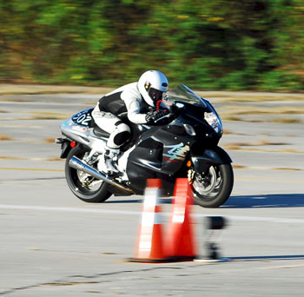
Racing at 192 mph
In August 2008, my husband Todd and I made our first trip to the Bonneville Salt Flats, home of LSR. We worked with the Seldom Seen Slim team and they allowed us to make licensing runs on their bike. In LSR, you license up starting at 125 mph in 25 mph increments, to establish that you can handle the speeds. I piloted their stock Kawasaki ZX-14 street bike to a speed of 185.194 mph. We had the time of our lives, running on the sacred ground where legends have run. (If you've ever seen the movie “The World's Fastest Indian,” you know the place.)

Do you see connections, between your IT career and LSR? When I started racing, the ECTA kept records by hand, with pencil and paper!!! With my programming and technical knowledge, I developed a Microsoft Access database that tracks our meets for the ECTA. I developed the database for free and donate my time maintaining it, as a DBA. The database holds the membership, registration, run logs and records for the current meet as well as ECTA history back to 2003. Although I now just serve as the back up, I maintained the organization’s Web site for many years. Once the data is finalized after every meet, I post the results to the Web site. We usually have our results on the Web within 24 hours. We are traditionally the fastest of all of the venues to get our meet results out to the public. This has raised the bar for the other venues, demonstrating that it can be done and that racers and race fans want it!
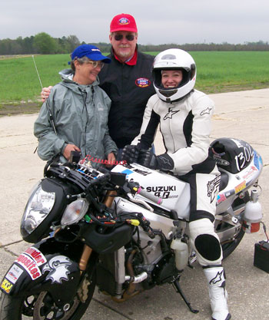
With sponsors and friends
Ellen and Scott Guthrie
Sounds like family and friends support your passion for racing. Are they all racing-related? My family just thinks it’s normal for me! I’ve been wrenching on cars since I was four, so naturally I had hot rods when I got my license to drive a car. My dad was a backyard mechanic, so I grew up helping him. Both my mom and dad were street racers when they were young. Once they had us kids they backed off on all the racing but we still grew up with a few fast street cars in the family! Since my friends are mostly from the racing community, they think it’s great. My co-workers at FEPOC are probably the ones who can’t imagine me riding a bike, much less racing at 200mph!
My 14-year-old daughter still thinks it’s cool that I race but she tries not to tell me that! She’s not really interested in racing, but she likes to hang out and socialize—since LSR is very family-oriented and family-friendly, so the kids love to come and hang out with the other kids at races.
What keeps you hooked on racing? I love working on my bike. I love running it fast. I love watching my husband run it fast, knowing that I built it and we both trust my work. The sense of accomplishment at working hard towards a goal and being able to achieve that goal while racing as an equal among my peers is awesome! It’s empowering to be able to compete and come out on top by achieving a record against equal competitors. And, the bike is a major source of pride for me, even when I’m not the pilot: Todd has run my bike to 207 mph faired and naked he has made three records in two classes (one was a bump, meaning he set the record in a class then ran faster and bumped that record to a higher speed).
Is LSR an equal-opportunity sport for both men and women? I grew up when girls didn’t drive hot rods! Shortly after I got my driver’s license as a teen, I bought a ’69 Ford Mustang hot rod with a 390-cubic-inch engine. Guys weren’t too keen on that and often put me down for it. When I finally got into LSR it was like coming home. It’s a place where I can finally, truly be myself and have that met with respect rather then disdain. But, comparing women motorcycle riders to men, I tend to think we have a bit of an advantage. Most of the women racers are smaller all around, so we can get out of the wind a lot better. That’s a great, natural aerodynamic advantage, which is very important in LSR. When it comes to female car drivers, I think our natural propensity to multi-task gives us the upper hand there as well! Personally I think the sport is biased in favor of the women! Lucky for the men, not too many women have figured that out … yet!
Debbie’s Racer Profile

Age: 41
Home: Stafford, VA
Occupation: Mainframe Computer Programmer
Years of riding a motorcycle: 9 years
Years of Land Speed Racing: 8 years
First time racing 200 mph: 2007
Fastest mph: 212.730
Race Vehicle: #1302 - 2006 Suzuki Hayabusa
Vehicle Owner/Designer/Builder: Debbie Dross
Entry Name: Twin Jugs Racing
Race Class: M/F-1350 & A/F-1350
Crew: Todd Dross
Everyday ride: 2006 Suzuki Hayabusa*, 2007 Buell Blast, 1999 Harley-Davidson Sportster
*Street legal, even in naked class!

Sponsors: Batts Racing, Boost by Smith, BrendanP, Brocks Performance, Busaman66, Canadian Mike, Cycle-Tek, Dave (DaveO) Owen, Decal Dreamz, Family Pizzeria, Hays Performance & Machine, Schnitz Racing, Scott Guthrie Racing, Spider Grips, Thunder Composites, Tiger Racing, Twin Jugs Cycle, Warp12 Racing

Debbie’s Records
Bike #1302  2006 Suzuki Hayabusa  (nitrous fuel)  Team: Twin Jugs Racing | A/F-2000/4  A/F-3000/4 | 191.709 | May-08 to May-08
 | A/F-2000/4  A/F-3000/4 | 202.351 | May-08

Bike #9551 - 2004 Honda Dream 50R  Team: Sea Eagle Racing | P/P-50/4 | 54.411 | Sep-07

Bike #851  2001 Kawasaki 125cc  Team: Williams/  Lone Eagle Racing | A/BF-125/4 | 63.033 | Oct-03
 | A/BG-125/4 | 62.653 | Oct-03
 | A/F-125/4 | 62.857 | Oct-03
 | APS/BF-125/4 | 62.995 | Oct-03
 | APS/BG-125/4 | 62.543 | Oct-03
 | APS/F-125/4 | 63.072 | Oct-03
 | APS/G-125/4 | 62.597 | Oct-03
 | M/BG-125/4 | 62.349 | Oct-03
 | M/F-125/4 | 63.146 | Oct-03
 | MPS/BG-125/4 | 62.579 | Oct-03
 | MPS/F-125/4 | 63.041 | Oct-03

Bike #1301 - 1968 Aermacchi Sprint SS 250  Team: Twin Jugs Racing | A/PF-250 | 64.923 | Sep-03 to Apr-06

Bike #936 - 1967 Aermacchi Sprint H 250  Team: Twin Jugs Racing | M/PF-250 | 76.489 | Oct-02 to Oct-05

Bikes that Debbie has run at Maxton without setting a record:

#1301 - 2003 Buell Blast 500cc (stock)
Team: Twin Jugs Racing
Top Speed: 97.005
May 2006

#1058 - 1986 Suzuki 750
Team: Umphlett/SNART Racing
Top Speed: 153.835
October 2006

#1103 - 1999 Suzuki Hayabusa Turbo
Team: Scott Guthrie Racing
Top Speed: 212.730
May 2007

#9044 - 2005 Triumph Bonneville
Team: Ken Presson Racing
Top Speed: 112.469
September 2007

Bike that Debbie ran at Bonneville for rookie passes and to license, without setting a record:
#214 - 2008 Kawasaki ZX14 (stock)
Team: Seldom Seen Slim
Top Speed: 185.194
August 2008

Debbie’s Links
- Debbie’s team racing Web site
- Debbie’s LSR history
- Photos of Debbie and her bike
- Photo of Debbie’s John Beckett Award for Member of the Year 2007
- Photo of the "Broken Bone" award Debbie received after breaking her collarbone in 2007
- Racer profile of Debbie
- Video that includes footage of Debbie’s 202.351 MPH pass
- On-board video view from pilot’s seat of Debbie making a 187 mph run
Further details, contact Debbie at extension 2328.

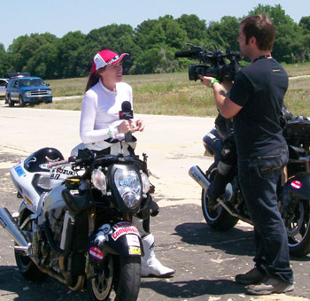
During an interview by Streetfire.net

